**Create The Enquiry Field**

1. Go to setup >>> click on Object Manager >> type object name in search bar >> click on

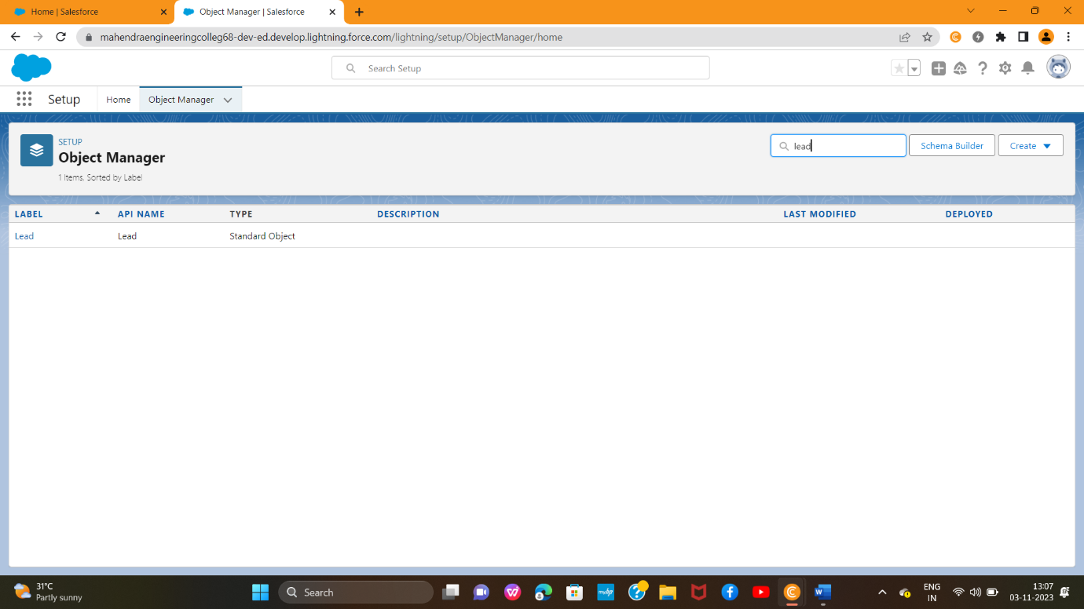

Now click on “Fields & Relationships ” >> New.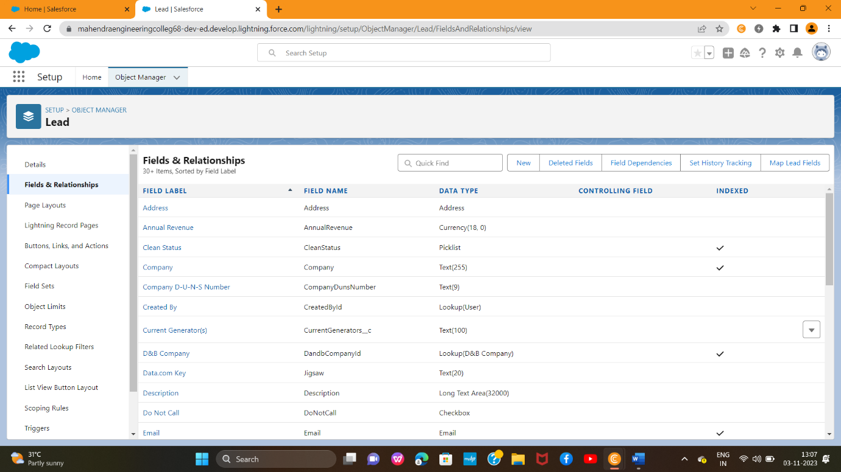

3 Select Datatype (Auto number)

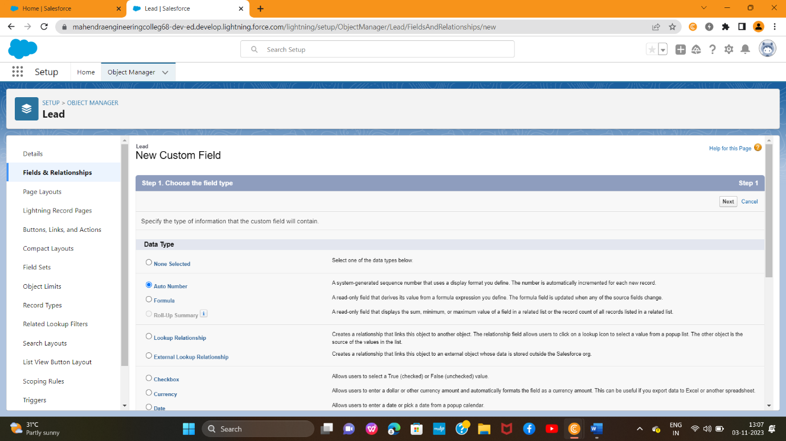

4 . Fill the field label name Enquiry Number,Datatype(autonumber) >> Next >> Next >> Save.

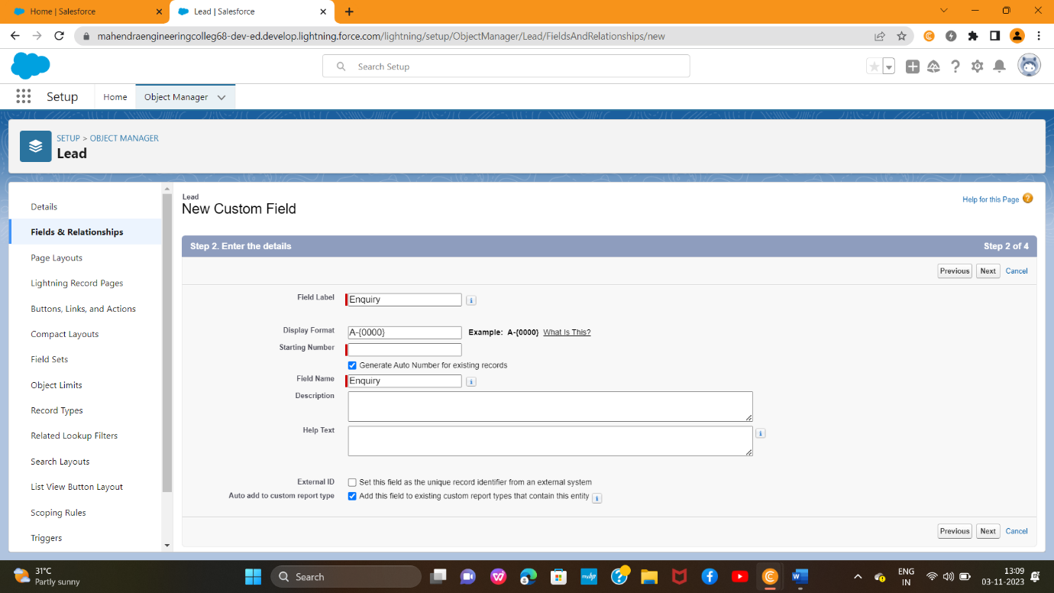

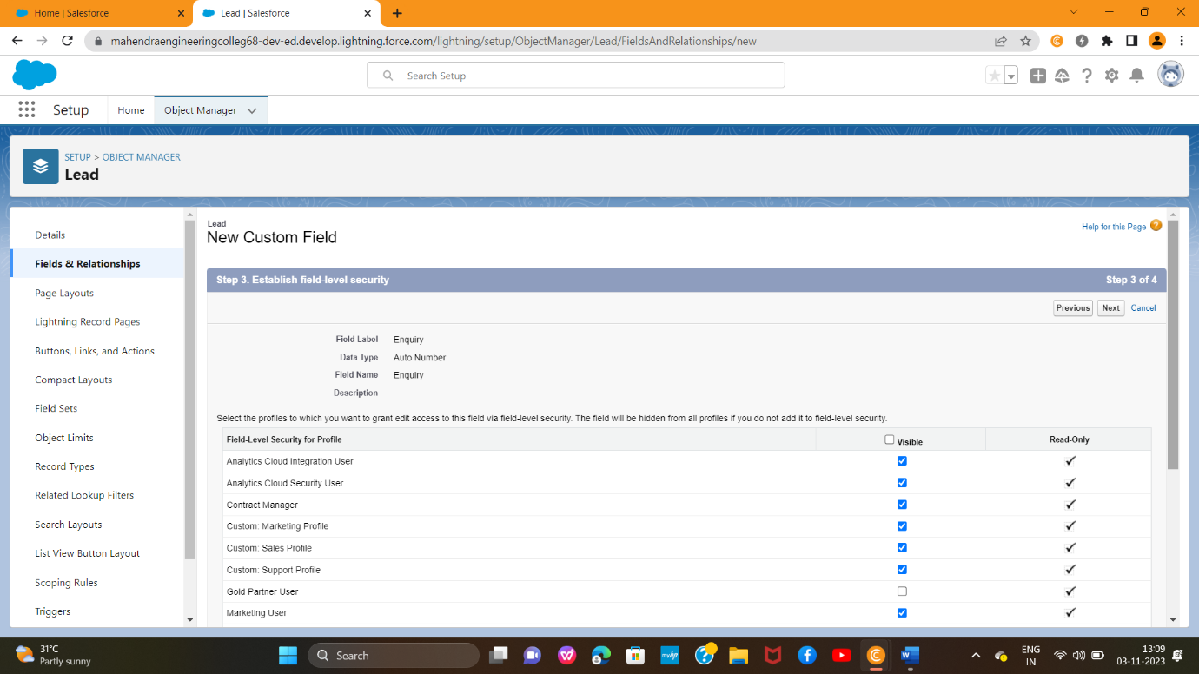

**Create the remaining Fields:**

Follow the above activity 1 Steps 1 to 2 , create the Field just change the Labels and data types for Below Fields

Enquiry **Type:** Create the picklist fields by the values(Buy,Rent)

**State:** Create the Picklist Fields (Maharashtra, Gujarat, Rajasthan)

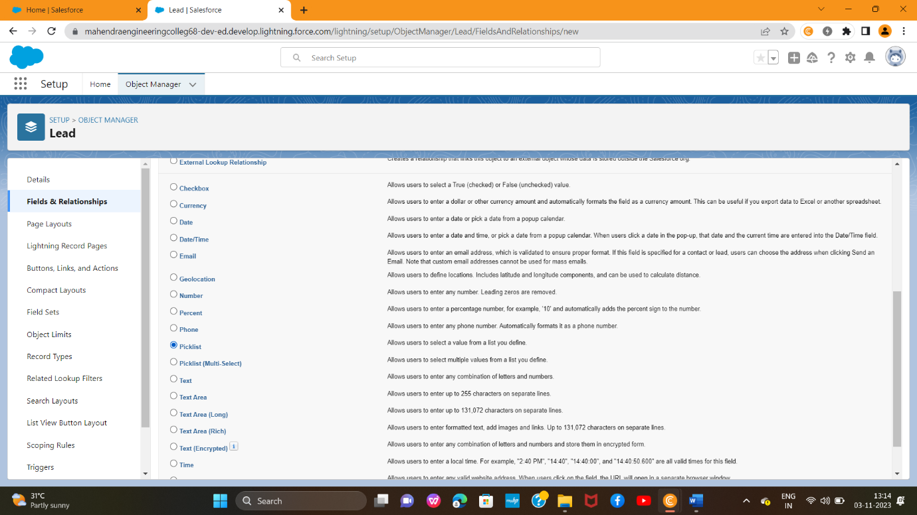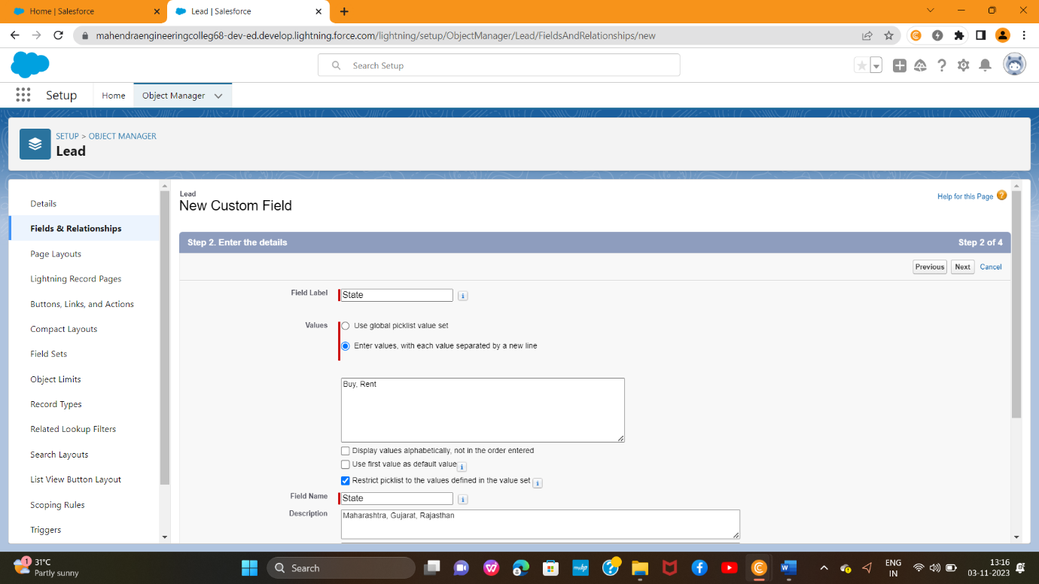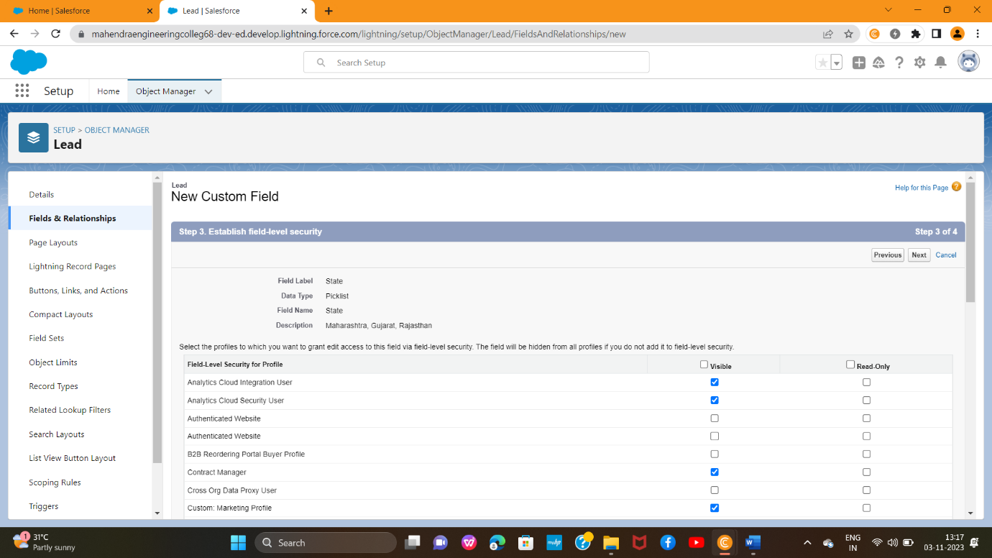

**City:**Create the Picklist Fields(Nashik, Surat,Jaipur)

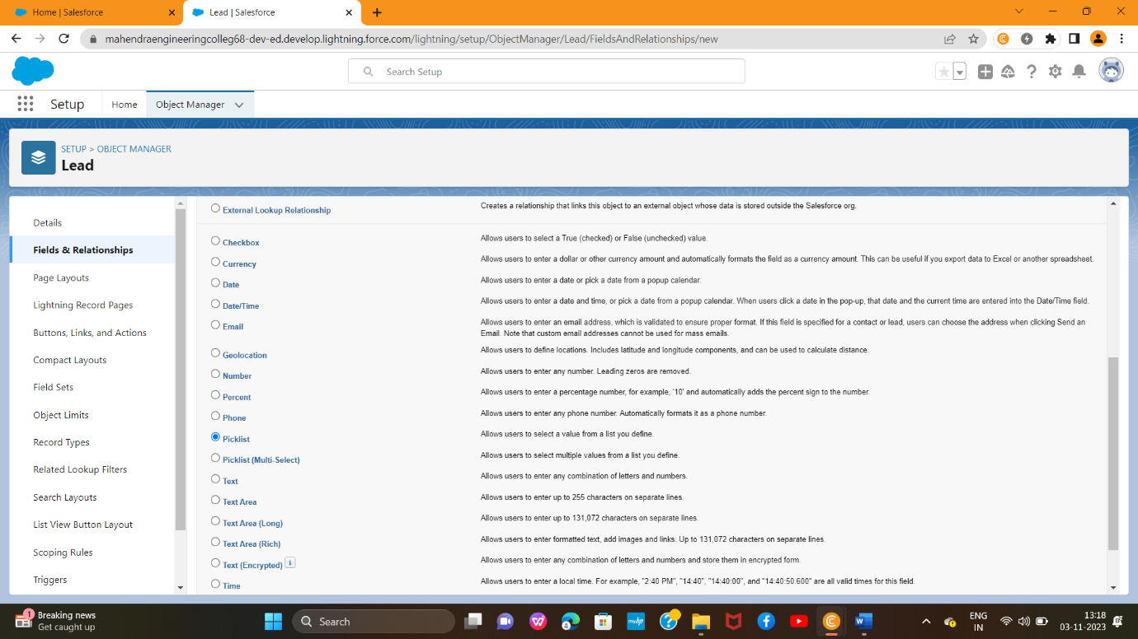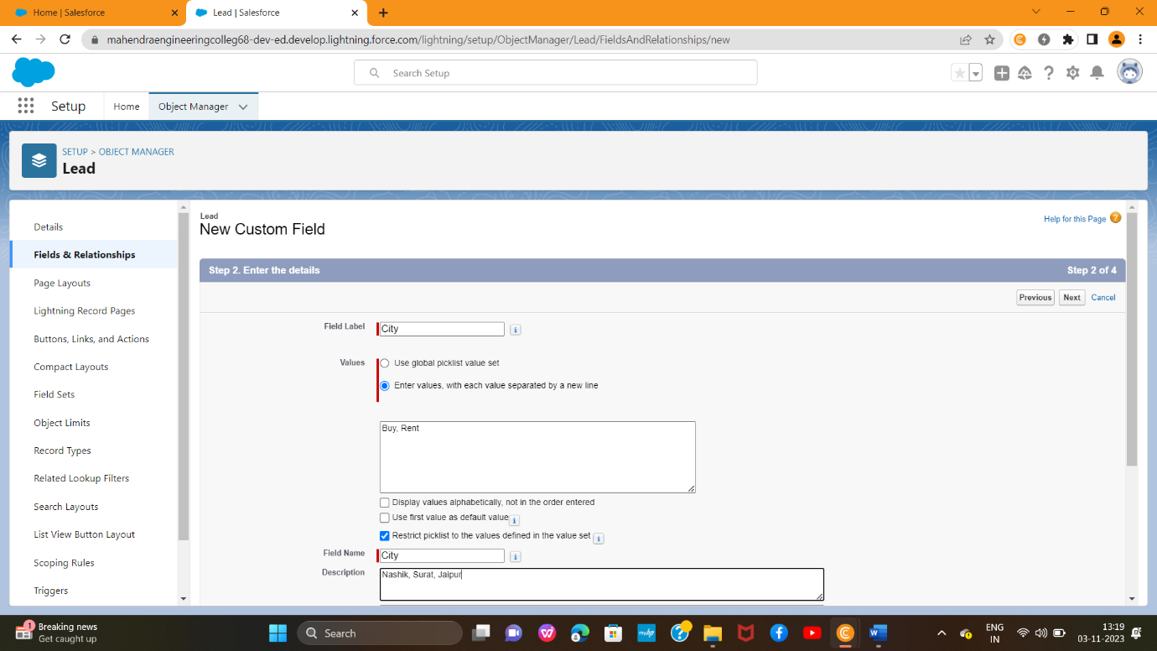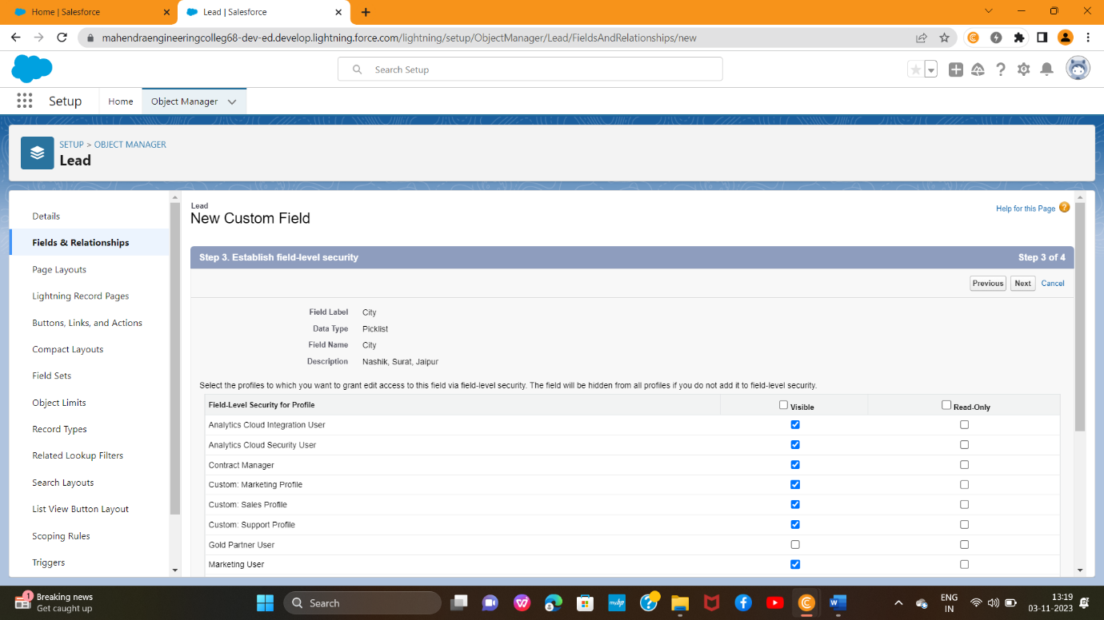

**Email:** Create the Email Select the Data Type As Email (Email) Phone: Select the Field Data type as (Phone)

